Week 1  Test on  06.06.25 | Week 2  Test on 13.06.25 | Week 3  Test on 20.06.25 | Week 4  Test on: 26.06.25 | Week 5  Test on: 04.07.25 | Week 6  Test on: 11.07.25 | Week 7  Test on:18.07.25
To spell words where the digraph ‘sc’ makes a /s/ sound | To spell words that are homophones | To spell words with irregular spelling patterns | To spell words ending in ‘-sion’ | To spell words with irregular spelling patterns | To spell Year 3 words (revision) | To spell Year 3 words (revision)
science  scene  discipline  fascinate  crescent  scissors  ascend  scented  scenery  descend | ball  bawl  berry  bury  break  brake  fair  fare  mail  male | accidentally  breathe  century  consider  eight  guard  heard  peculiar  possible  quarter | division  invasion  confusion  decision  collision  television  erosion  vision  fusion  revision | special  strange  difficult  important  length  perhaps  position  pressure  purpose  question | pleasure  island  dislocate  disadvantage  decide  survey  exactly  bravely  ordinary  promise | scented  grotesque  daily  freight  hourly  missed  suppose  plaque  descend  automatically

Practicing Spelling at Home
Little and often is the best approach, just a couple of minutes a day can make a huge difference. Focus on the words you find trickiest, you could list them from easiest to hardest and focus on the hardest spellings. If you can spell a word very easily, chose a trickier word to practice. See some examples of how to practise on the back of this sheet.
And remember. Mistakes help your brain grow!
Order and test yourself | Multi-sensory sand or salt tray | Water painting
  Order the words from easiest to hardest, then ask a helper to read out the words for you to practise. | 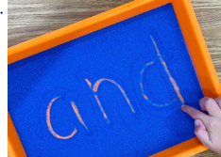  Write the words using your finger or a stick in a tray of sand or salt. A coloured tray or dish makes it easier to see. |   Or use a paintbrush and water and ‘paint’ the word on an outdoor wall or pavement.
Timer challenge | Pattern spotting | Sound buttons
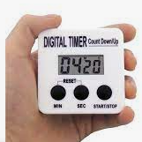  Set a timer for 2 minutes, ask a helper to shout out the words and see how many you can spell correctly in the given time. | Official  Underline or highlight the pattern we are learning, then apply this to new words with the same pattern.  Practice the pattern, if you can spell this correctly you should be able to spell the words fairly easily. | 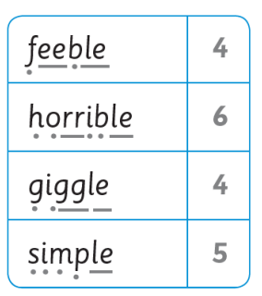  Use your phonics knowledge to identify the sounds in each word.  Use a dot if 1 letter makes one sound.  Use a dash if a sound is made up of 2 or more letters.  If there is a split digraph (where another letter is in the middle) we use .  If a letter is silent circle it  Then count the number of sounds in the word

