Dra
Use the interactive map to learn more about the UK
https://mrnussbaum.com/france-interactive-map

Use this link to learn more
https://www.globetrottinkids.com/countries/france/
Year 3 Homework Grid
Term 6
Our exciting new term is based around our Geography unit: City of Lights. Below is a list of possible homework ideas you are invited to create with your child over the next term. We would expect at least 4 pieces of homework to be completed each term. There will be an opportunity each Friday for your child to share any work they have produced in class.
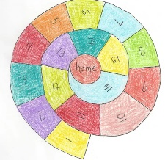  Maths  Make and play a French playground game  of ‘Escargot’.  You could even practice your numbers  in French.  Here is how to play: https://weefolkart.com/homeschool/play-french-escargot-game/ | Writing  - Research a famous landmark in Paris and create a tourist leaflet about it.  - Write a persuasive paragraph about why we should visit Paris.  - Write a postcard or a letter as if you are visiting Paris, tell your family all about what you have seen and done. | 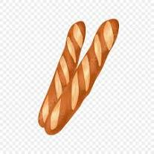  Health and Well-Being Task  Research what French children eat for breakfast, lunch and dinner.  Do they have snacks?  Write a healthy menu based on what you have found out.
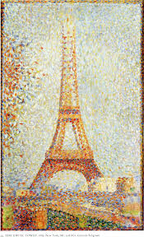  Art  Look closely at some of the Pointillist paintings by the French artist Georges Seurat.  Learn some facts about the life and work of Georges Seurat.  Recreate some of his art work yourself, in the style of pointillism. | Map Task    Use Google Maps to explore Paris.  Which landmarks can you spot?  Are there any rivers or mountains in/near Paris? | Read  Read about Paris on this website: https://kids.britannica.com/kids/article/Paris/345991  Or read a book set in or about Paris. Here are some ideas: https://kidstravelbooks.com/best-childrens-books-for-a-trip-to-paris/
D/T  - Try out a French recipe. (https://www.monpetitfour.com/easy-french-recipes/). You could take some photos to share in school.  - Build a model of a famous Paris landmark. You could try: the Eiffel Tower, the Arc de Triomphe or even the Louvre. | Music  Research a popular French song. Listen and appraise:  Where would you use this music? ...  Think about who wrote the piece of music. ...  Can you feel the beat for the music? ...  Can you identify any voices or different instruments in the music? ...  Can you find out more about this musical style of the piece of music? | Research  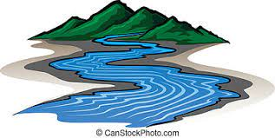  Find out information about a famous river, coast or mountain in France. Present this information in your preferred style e.g. PowerPoint, video presentation, leaflet, poster etc.

